ES0 203A INTRODUCTION to EE 10.2.17
TUT5
Q1. The following data has been obtained from the open circuit test of a small transformer.
Terminal voltage, V | 200 | 150 | 100 | 50
Frequency, Hz | 50 | 37.5 | 25 | 12.5
Power input, W | 55 | 38 | 23 | 10.25
Calculate (a) the hysteresis and (b) the eddy current losses for frequencies of 60, 50 and 25 Hz.
Ans: (a) 44.4, 25.9; 37, (b)18; 18.5,4.5 W
Q2: A three phase core type transformer is has a turns-ratio of 1200:100.The primary winding is star-connected and is supplied from a three phase 6600 V bus. The secondary winding is connected in delta and supplies a balanced resistive star load. If the primary line current is 10A, calculate (a) the secondary line and phase currents and (b) the three phase supplied by the transformer.
Ans: (a)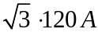, 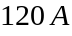 (b) 114.3154 kW
Q3: In the magnetic circuit shown the coil F2 is supplying 500AT in the direction indicated. Find the AT (in magnitude and direction) that the coil F1 must provide to produce a flux of 4mWb in the air gap in the central limb from A to B. The relative permeability of the core is 4500.
Ans: .The direction in which it must act is from B to A.

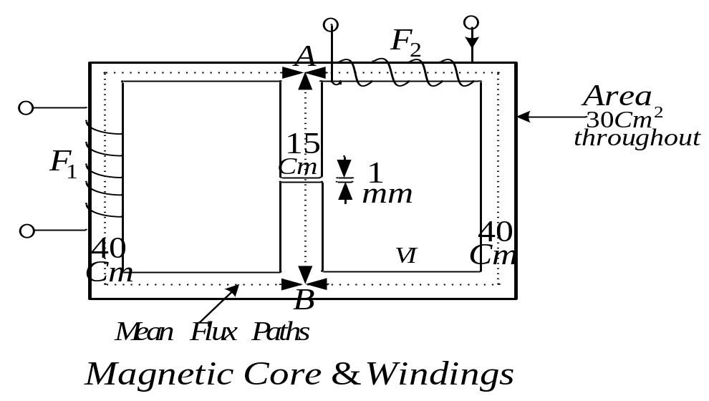

Q4: A 20KVA 2400/240V two winding transformer has an efficiency of 97.5% at full load 0.8 p.f. It is then connected as a step-up 2400/2640V autotransformer.
For operation as autotransformer, (i) calculate the rated KVA and the ‘conducted ‘KVA. (ii) Determine the efficiency for full load unity p.f. operation.
Ans: 220KVA, 200KVA, 0.9981

Q5: A short circuit test on a 100 KVA, 6600/330V,50Hz, single phase transformer is performed on the HV side. The test data is 100V, 10A, 436W.
Calculate the voltage to be applied to the HV side on full load at 0.8p.f.lagging when the secondary terminal voltage is 330V.Calculate the regulation.
Ans: 6735.2V, 2.05%

